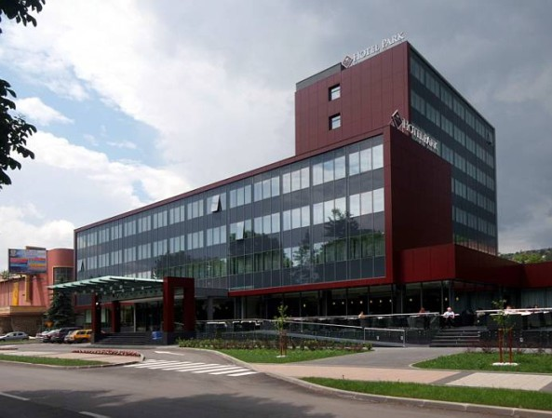

Owing to its geographic position at a crossroads of all major transport routes in BiH, the City of Doboj has excellent potential in the development of business tourism. The city has three hotels with capacities for organizing business events, four motels, three lodging establishments, and some rural tourist-oriented accommodations.

Within the scope of business tourism, City of Doboj offers team building events with the aim of developing team spirit, corporate outdoor activities, wellness activities and rural tourism.

According to the Tourist Board, City of Doboj is visited by thousands of day visitors and transit travellers every year. In 2018, City of Doboj visited 6323 domestic tourists and 8096 foreign tourists, registering total of 23081 nights spent. In 2019, City of Doboj visited 6237 domestic tourists and 8582 foreign tourists, registering total of 24201 nights spent.

CITY OF DOBOJ

Department of Economy and
Social Affairs
Hilandarska 1
Phone 053/242-022
Fax: 053/242-002
E-mail: privreda@doboj.gov.ba

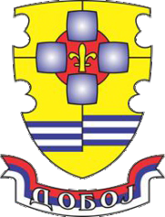

Updated March 2020.

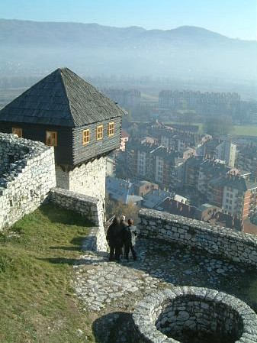

CITY OF DOBOJ

Tourism Guide

Tourism in the City of Doboj
City of Doboj is located on three rivers - Bosna, Usora and Spreca. Geographically, it is a speciﬁc mixture of valleys, hills and low mountains, and it has a rich cultural and historical heritage.

The Doboj fort is the most important tourist attraction in the city. The document which ﬁrst mentions the name Doboj and the fort is a letter sent from the Dubrovnik Republic to a Hungarian tzar and king Sigismund dated June 28th 1415, “…in Uxora subtus castrum Dobuy…”, noting that the Hungarian army was camped in Usora under the Doboj fort during its war campaign in Bosnia. The fort's construction began in 13th century, which is corroborated by numerous archaeological excavations, archaeological finds of jewellery in a cemetery in Usora and ceramics found at the bottom of the fort's south tower. Austrian gravures from 1697 and all Turkish censuses are evidence of the fort's existence over the centuries.

One of the tourist attractions in City of Doboj is Royal Village Kotromanićevo, located in the valley of a small river Veličanka, in the Vučjak foothill.

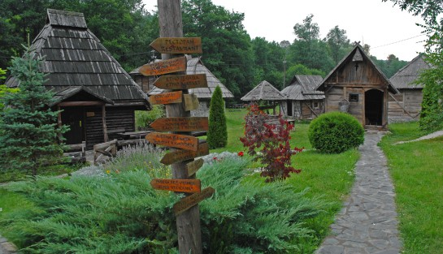
Numerous sporting, cultural and entertainment events are held in City of Doboj each year. These events are mostly traditional and attended in significant numbers by the public.
In the sport of handball, the International handball TV Tournament of Champions has become synonymous with Doboj, being one of the best and most renowned handball tournaments in the world. The tournament has been held since 1965 and for over half a century has consistently attracted the best handball teams in Europe.

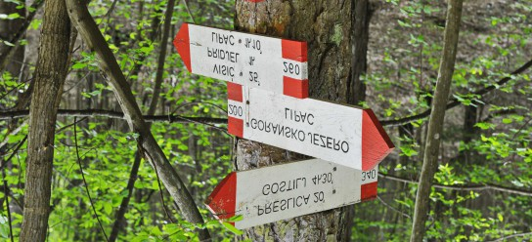

,,Teatar fest” is a theatre festival, when the most popular theatrical productions from BiH and the region are performed before full houses in the local Arts centre.

Certainly, worth mentioning and attending are:

- Christmas-New Year futsal tournament
- The days of the wolf on mountain Ozren
- St. George race day
- Tennis tournament “Doboj open”
- Paragliding competition
- Tea day on mountain Ozren
- International folklore festival
- Fish stew festival (fish festival)
- Gastro festival

Within the scope of rural tourism, Ozren mountain oﬀers a variety of ecotourism activities that provide a combination of nature and adventure activities. Bike riding, forest hiking, photo-safari, swimming in the lake, mountain trekking and paragliding are some of the activities on offer and in addition to being for fun and leisure they also take the participant closer to nature and promote understanding of natural life.
Ozren mountain, located in northern Bosnia, is characterised by sprawling slopes, lush pastures, thermo-mineral springs, clean mountain streams and numerous small rivers that flow through pine and oak forests. The climate is moderately continental with warm summers and cold and sharp winters.
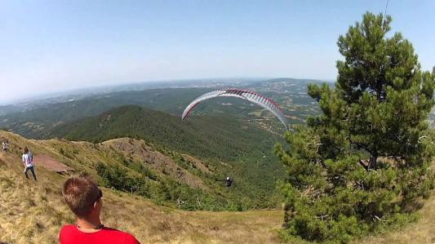

Days of the wolf on Ozren, held in February, is a traditional event held for many years and attracting more than 1,000 huntsmen from the countries in the region. Besides hunting, there are inevitable socialising and leisure experiences and enjoyment in the gastronomic oﬀer of Doboj.
